Assessment Schedule – 2015

Calculus: Apply integration methods in solving problems (91579)

Evidence
Q1 | Expected Coverage | Achievement  u | Merit  r | Excellence  t
(a) | 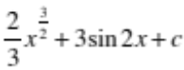 | Correct integral.
(b) | 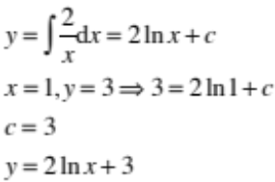 | Correct solution with correct integral.
(c) | 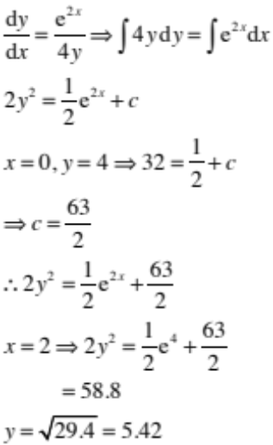 | Correct integral. | Correct integral and correct solution.
(d) | 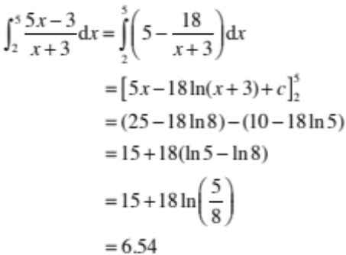 | Correct integral. | Correct solution with correct integral.

Q1 | Expected Coverage | Achievement  u | Merit  r | Excellence  t
(e) | 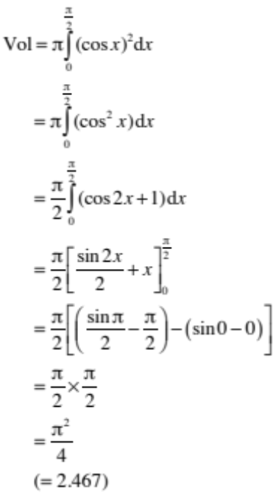 |  | Correct integral (3rd line). | Correct solution with correct integral.

NØ | N1 | N2 | A3 | A4 | M5 | M6 | E7 | E8
No response; no relevant evidence. | ONE answer demonstrating limited knowledge of integration techniques. | ONE correct integration. | 2u | 3u | 1r | 2r | 1t with minor errors ignored. | 1t

Q2 | Expected Coverage |  | Achievement  u | Merit  r | Excellence  t
(a) | 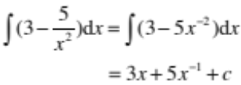 |  | Correct integral.
(b) | 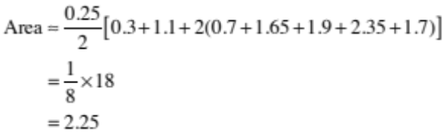 |  | Correct solution.
(c) | 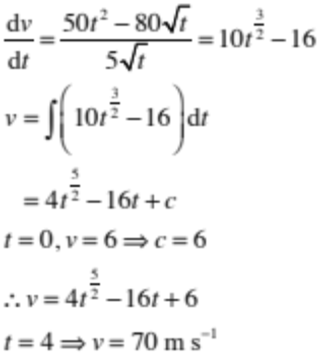 |  | Correct integral. | Correct integral and correct solution.  Units not required.
(d)(i)  (ii) | 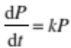  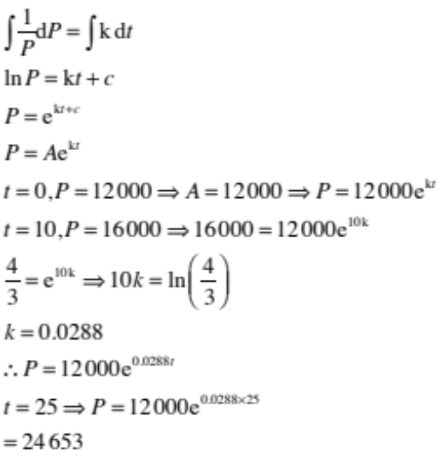 |  | Correct differential equation in (i) and correct solution to DE (line 3) in (ii). | Correct DE in (i) and correct solution to DE (line 3) in (ii).  Plus correct solution.  Final value may vary depending on rounding of k.
(e) |  | 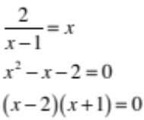  or  The point we want is .  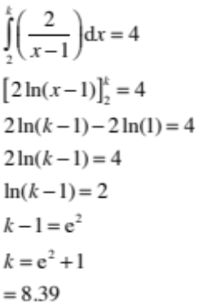 | Correct line 7, but with incorrect or no limits. | Correct integration with correct limits substituted. | Correct solution with correct integral.  Accept  e² + 1.

NØ | N1 | N2 | A3 | A4 | M5 | M6 | E7 | E8
No response; no relevant evidence. | ONE answer demonstrating limited knowledge of integration techniques. | ONE correct integration. | 2u | 3u | 1r | 2r | 1t with minor errors ignored. | 1t

Q3 | Expected Coverage | Achievement  u | Merit  r | Excellence  t
(a) | 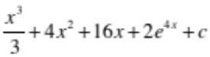 | Correct integral.
(b) | 1 | Correct solution.
(c) | 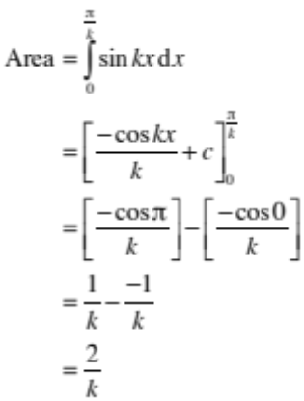 | Correct integral. | Correct integral and correct solution.
(d) | 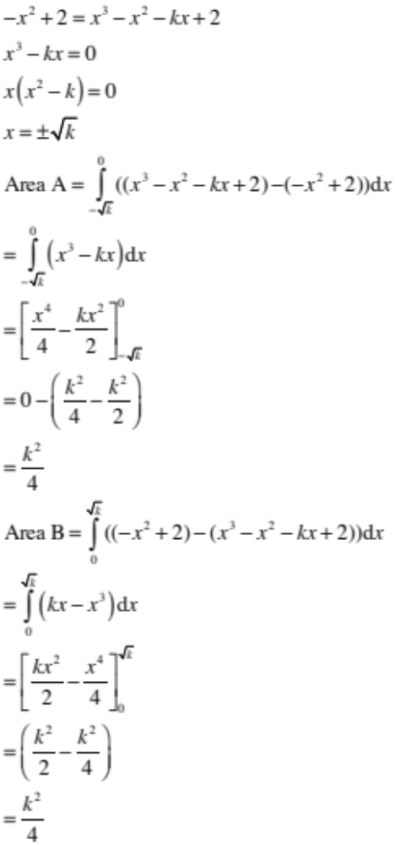  Therefore both regions have the same area. | Correct integration – either region. | Correct solution with correct integrations.

(e) | 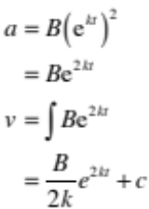  At t = 0, v = 0  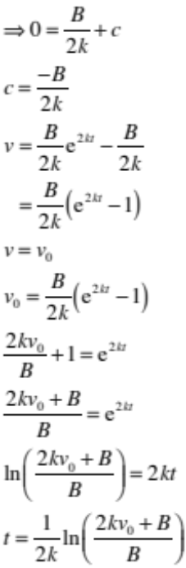 |  | Correct integration (4th line). | Correct solution.

NØ | N1 | N2 | A3 | A4 | M5 | M6 | E7 | E8
No response; no relevant evidence. | ONE answer demonstrating limited knowledge of integration techniques. | ONE correct integration. | 2u | 3u | 1r | 2r | 1t with minor errors ignored. | 1t

Cut Scores
Not Achieved | Achievement | Achievement with Merit | Achievement with Excellence
0 – 6 | 7 – 13 | 14 – 20 | 21 – 24

